Task 1 Output:

Average TF for "applicant" in Wikipedia: 5.6573498667649845e-06
Average TF for "and" in Wikipedia: 0.03343681108797148
Average TF for "attack" in Wikipedia 0.000197226548759146
Average TF for "protein" in Wikipedia 4.753928044716984e-05
Average TF for "court" in Wikipedia 0.0003936548624344322

Average TF for "applicant" in Australian Court: 0.0044491616810928
Average TF for "and" in Australian Court: 0.020399611297455933
Average TF for "attack" in Australian Court 3.851080058563264e-05
Average TF for "protein" in Australian Court 2.9486677193617493e-06
Average TF for "court" in Australian Court 0.005215688305338147

Spark History:

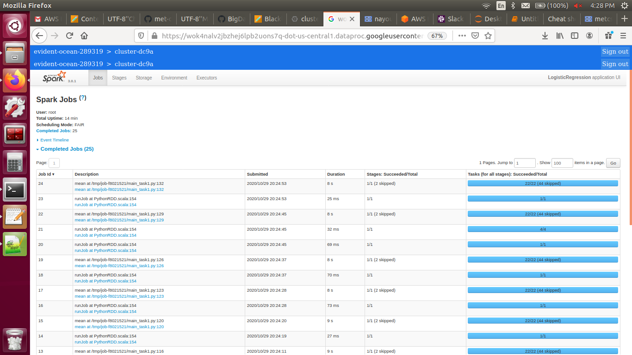

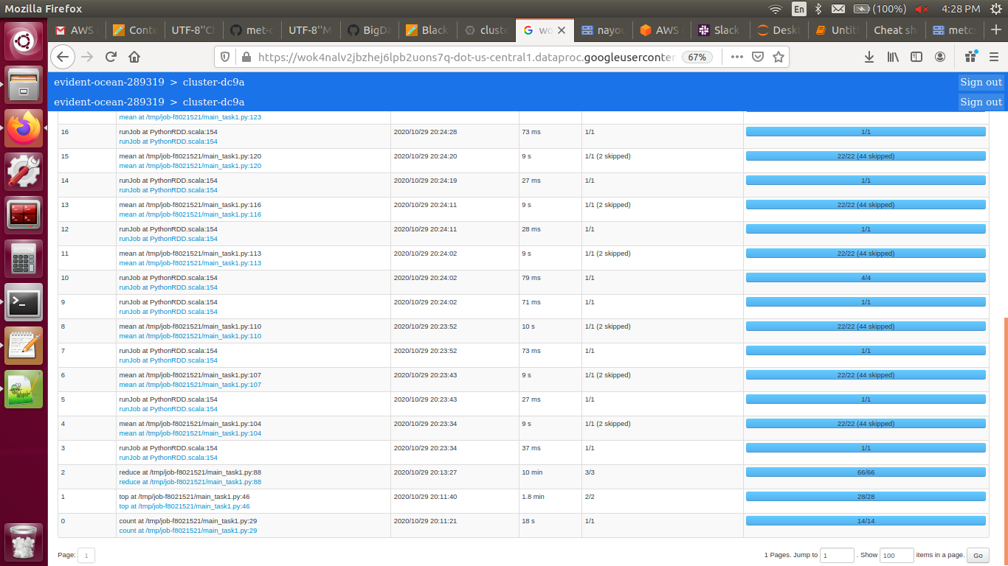
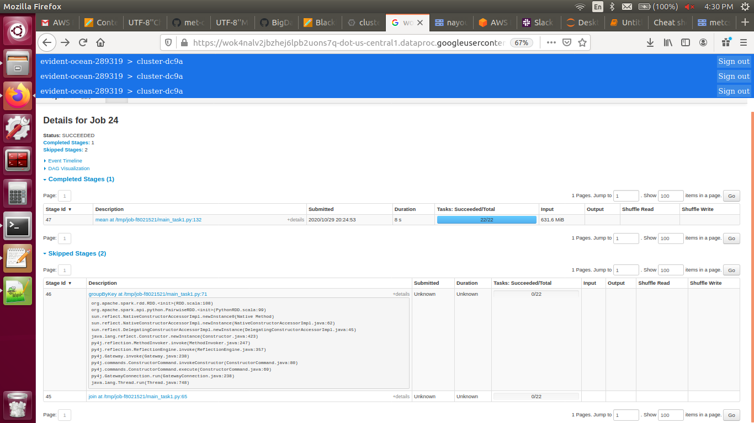

Task 2 Output:

Cost stopped decreasing at: 200
Top 5 words most strongly related with an Australian court case:
[('mr', 141), ('applicant', 448), ('relation', 1021), ('pty', 1597), ('clr', 3250)]

Spark History:

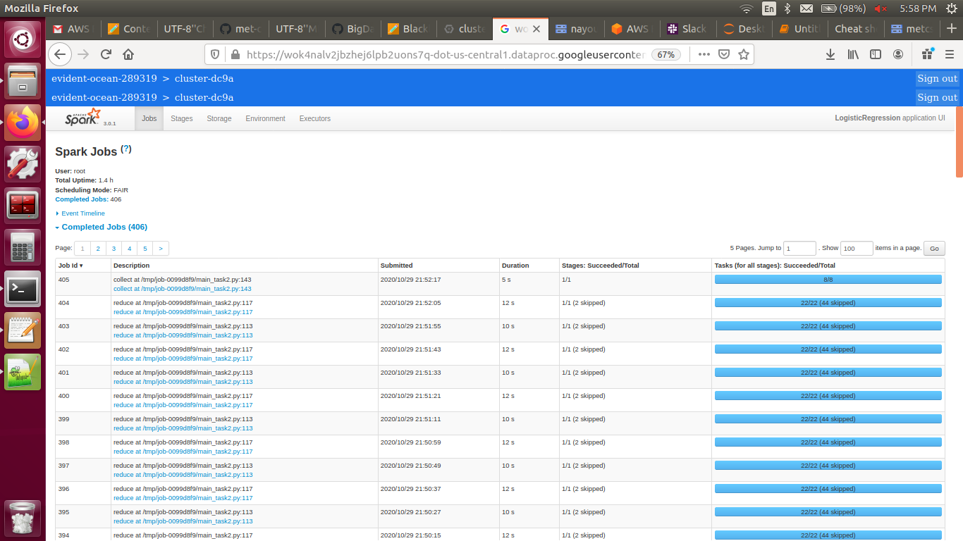
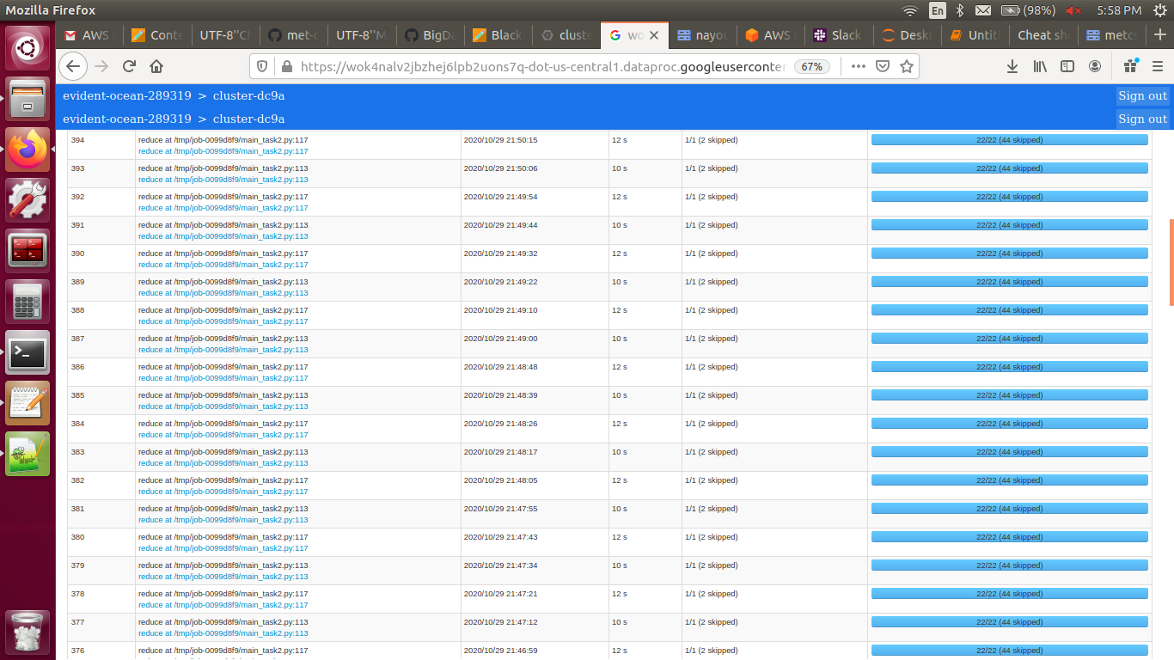
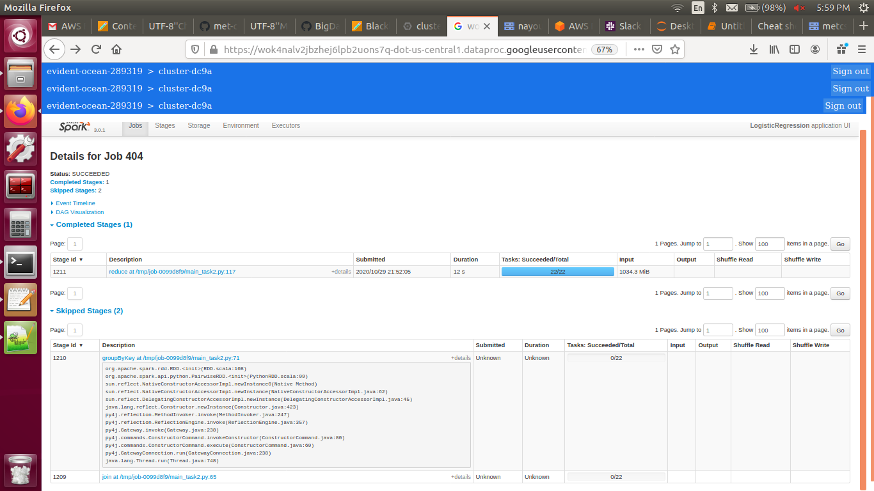

Task 3 Output:

Cost stopped decreasing at: 200
F1 score: 97.72 %
IDs for False Positives: ['14683768', '35810670', '38262801']

14683768 – Hog’s Breath Cafe: The article is about an Australian chain of steakhouse restaurants and I believe the model flagged it as 1 (Australian court document) instead of 0 because it mentions the words “Australia”, “Australian”, etc. as well as multiple Australian cities throughout the article. In addition to that, according to Task 2, “Mr” is one of the top 5 words that are most strongly related with an Australian court case and it is mentioned many times in this article.

35810670 - Smit v Abrahams and 38262801 – Kragga Kamma Estates v Flanagan: Both these articles refer to important cases in the South African law where a lot of legal terms are mentioned which could cause the model to confuse it with Australian court documents.

Spark History:

